**DAY 4 CYBER SECURITY ASSIGMENT**

**QUESTION 1 :**

**Find out the mail server of the following domain**

**Ibm.com**

**Wipro.com**

**ANSWER :**

**For finding the Mail server I used nslookup in mu command prompt in my system**

**Start > Run > cmd**

**Commands:**

**C:\Users\Rohit>nslookup**

**>set type=mx**

**>ibm.com**

**# The Result is attached below as an image ….**

**>wipro.com**

**#The Result is attached below as an image ….**

**RESULT FOR WIPRO.COM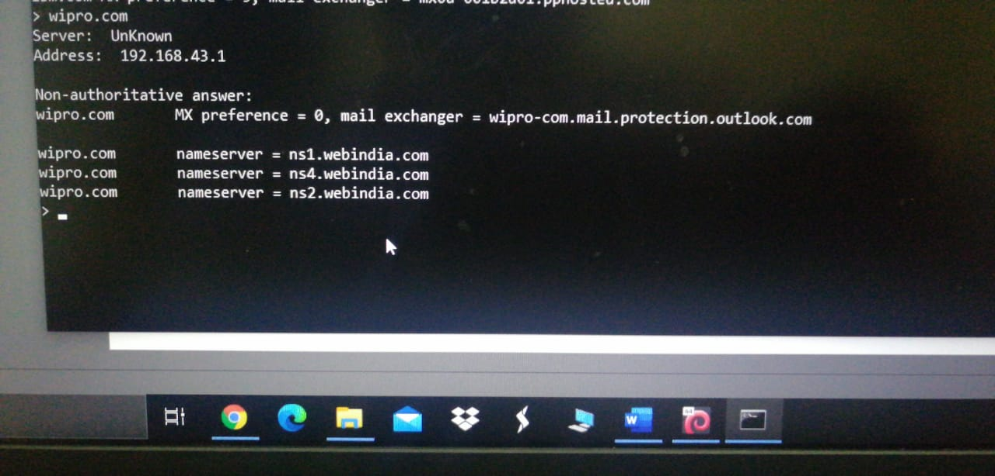 RESULT FOR IBM.COM**

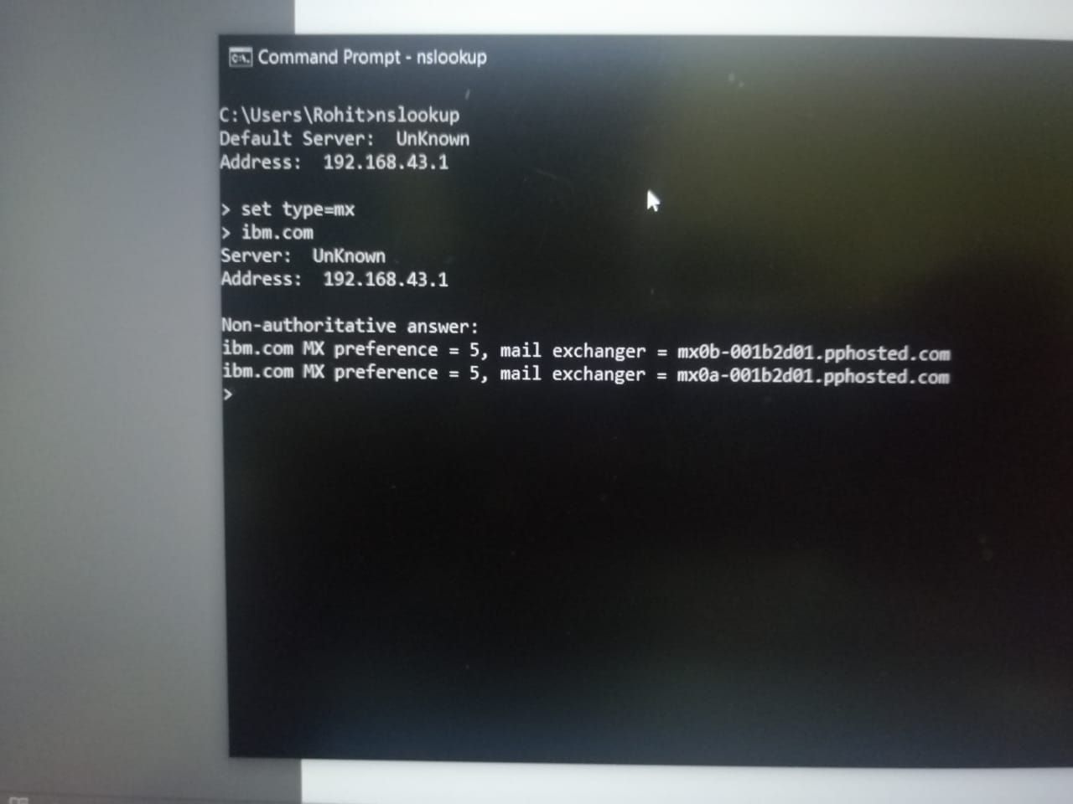

**QUESTION 2:**

**Find the Location where these mail servers are hosted**

**ANSWER :**

**WEBSITE USED :** <https://www.iplocation.net/ip-lookup>

**In Search box and the Location of the For this one I use iplocation.net in Google and I entered the Mail server name is displayed as a result**

**FOR IBM.COM**

**Mail Server name : mx0a-001b2d01.pphosted.com**

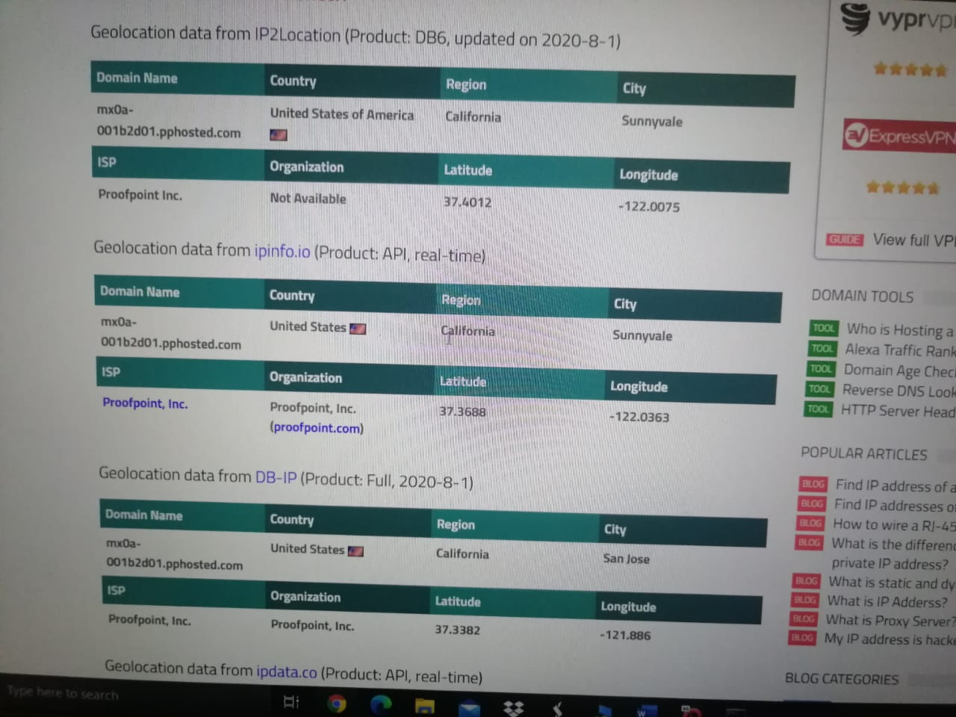

**FOR IBM.COM**

**Mail Server name : mx0b-001b2d01.pphosted.com**

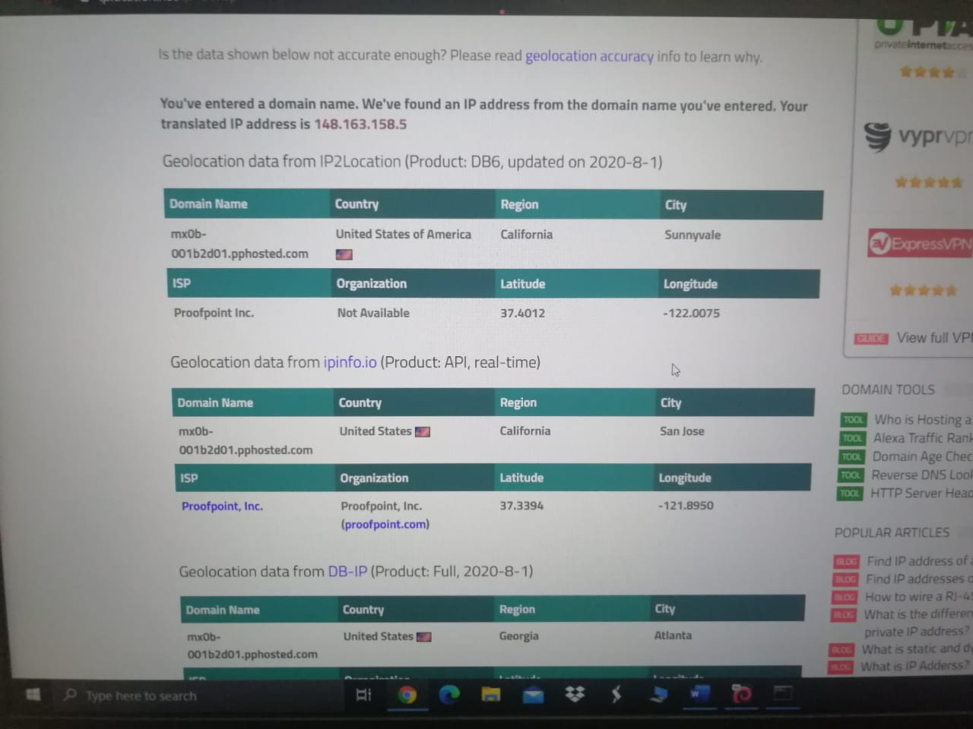

**I uploaded two images for ibm.com as it has two mail server and I found that using nslookup and I used** [**https://www.iplocation.net/ip-lookup**](https://www.iplocation.net/ip-lookup) **to locate for the mail server and I searched for both the server and I uploaded as an image and finally I came to know that the ibm.com using the mail server which is located in United states……….**

**FOR WIPRO.COM**

**Mail Server name :** **wipro-com.mail.protection.outlook.com**

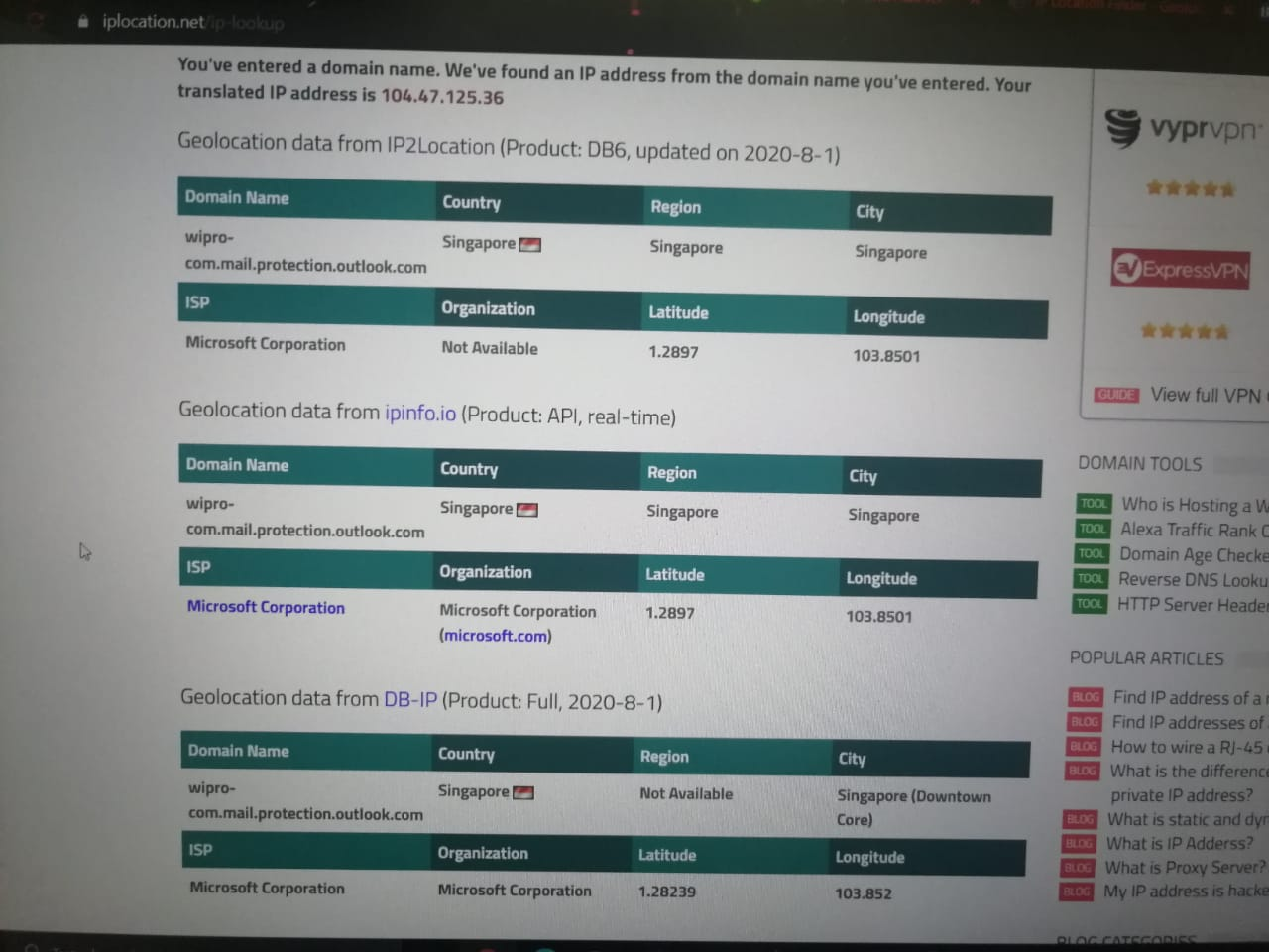

**I uploaded image for wipro.com and I found mail server using nslookup and I used** [**https://www.iplocation.net/ip-lookup**](https://www.iplocation.net/ip-lookup) **to locate for the mail server and I searched for the server and I uploaded as an image and finally I came to know that the wipro.com using the mail server which is located in Singapore……….**

**QUESTION 3 :**

**Scan and find out the open port numbers 203.163.246.23**

**ANSWER :**

**Cannot ping the ip address sir as icmp packet is refusing my request ….so that I cannot find the open ports using nmap sir and the error image is attached below**

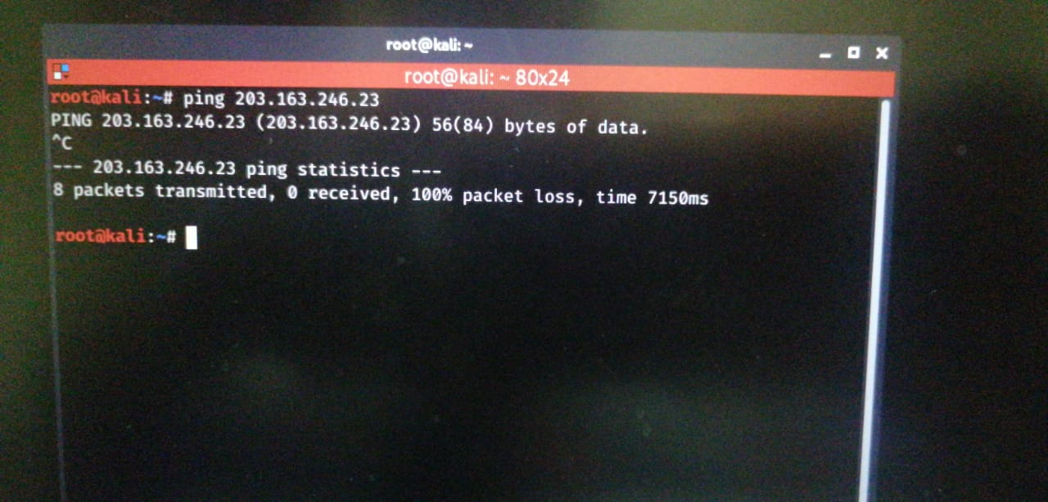

**Even used online Tools to scan open ports sir ……but I got a same error**

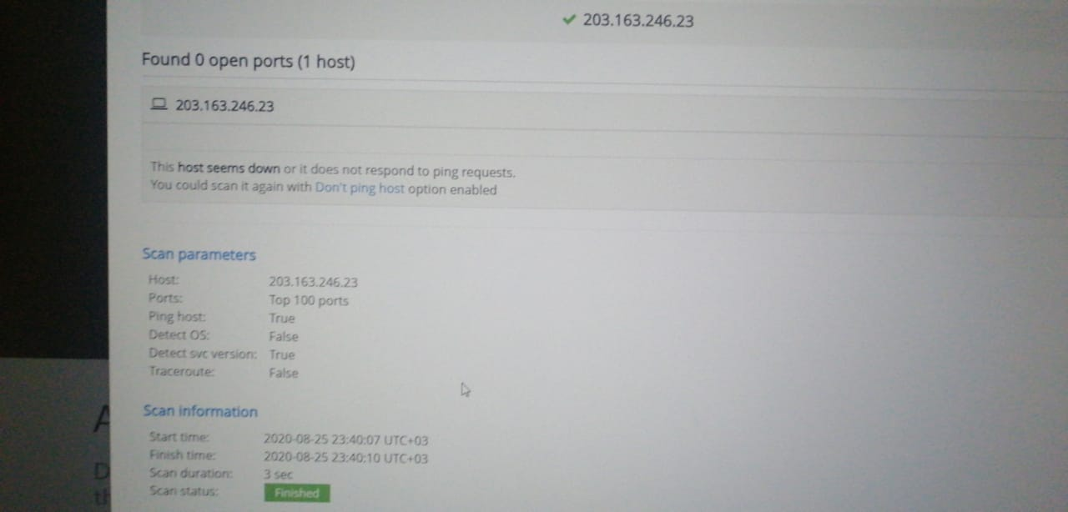

**QUESTION 4:**

**Install Nessus in a VM and scan your laptop/pc for cve**

**ANSWER:**

**I installed Nessus Essentails in my laptop sir and I runned a scan against my laptop and here is the result…………**

**I have done a scan against my device sir and I got this result and I generated my report in html format sir ……….**

**BASIC SCAN : (ON KALI LINUX)**

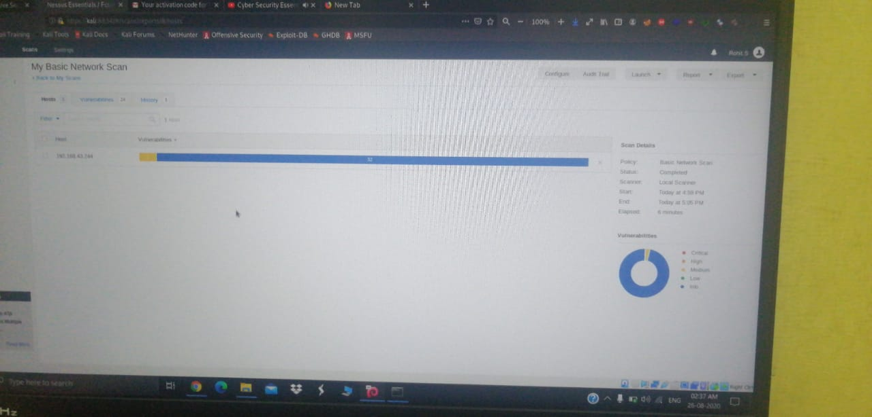

**ADVANCE SCAN ( ON WINDOWS) :**

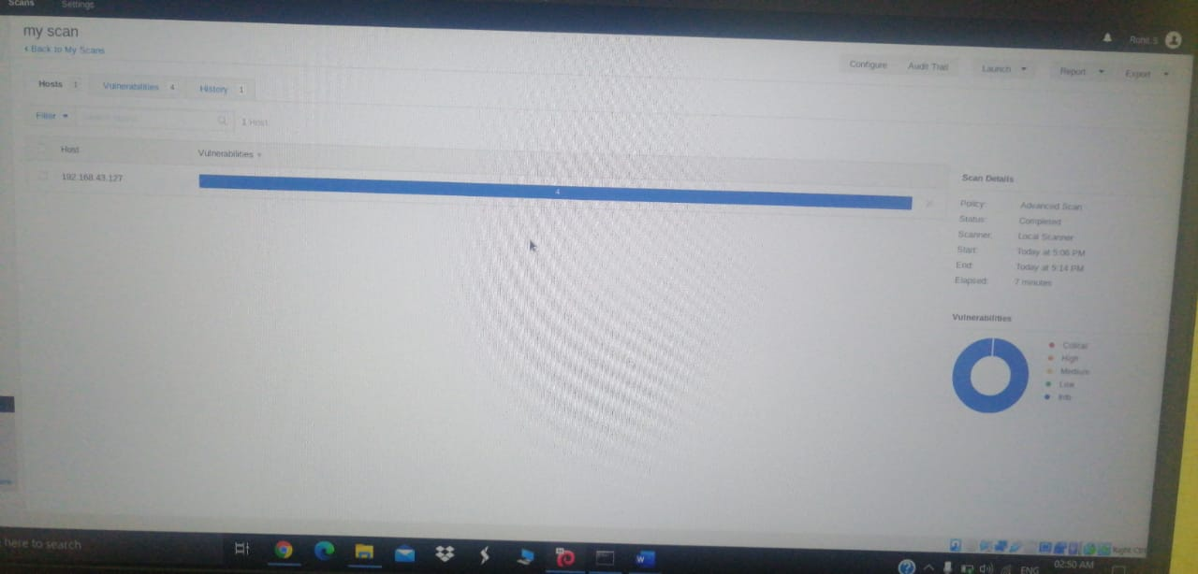

**And I generated a report as html and pdf format sir ……………**

**-THANK YOU SIR**

**-THANK YOU SIR**